Various KiCad-related notes.

Looking to assign Footprints

This gets me every time, and I spend ages hunting for how you assign a 3D model to a component / symbol.

- If it is a standard component, then KiCad will probably find it.
- If you need to assign a bespoke 3D model, do the following:
  - Make a copy of the Component in a personal Global footprint Library
  - Open the footprint in the footprint editor
  - Click on File > Footprint Properties
  - 3D Models are added in the 3D Models tab

- NOTE: KiCad seems to be unable to some older libraries

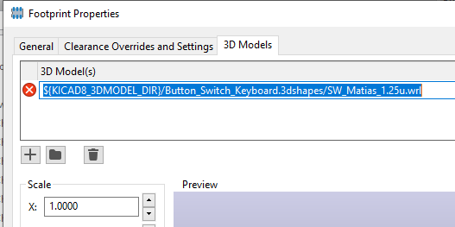
- The ${KICAD_3DMODEL_DIR} environment variable is pointing to the following location:

C:\Program Files\KiCad\8.0\share\kicad\3dmodels

- The error simply means that there is no .wrl file in that directory

